* 1. Student Fees Types

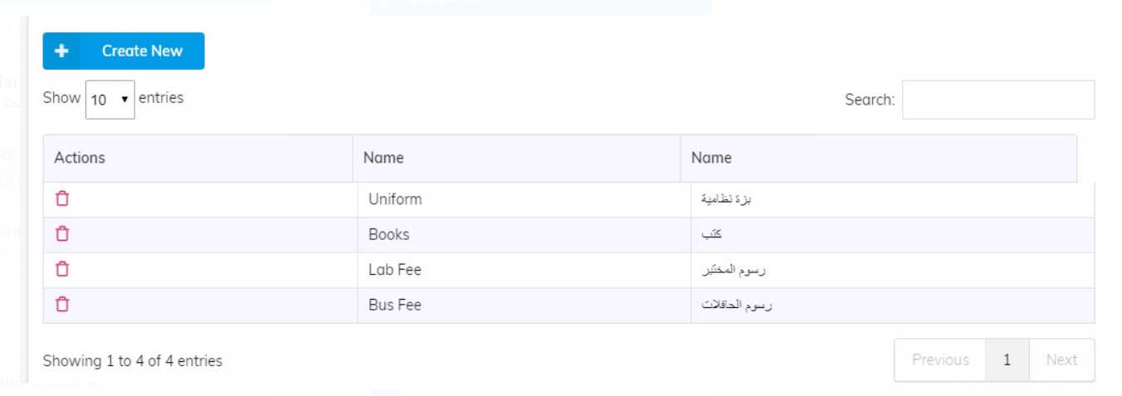

We shouldn’t have a separate page for declaration

this is not the appropriate place for them because: these types are the operating income of the school and therefore must appear in the (Accounts Chart) in the segment of revenue. and therefore suggested change as explained

2.1



We take much time in each page of selecting student

The app should show the current study year and the grid should contains all student of the this year and when search will get the student. To make actions

2.3 Student Configuration

Will remove it from here

And in the student page will have action button

2.4

Student’s Registration cycle should start from the ERP

Link the icons in the documentary cycle such as offer letter, results placement test and application, as well as collection bonds, until the copy of the contract with the guardian and issuance of permission to exchange from the stores and then introduce the student to the academic section of the program schools AS:

Step 1,2,3,4 will be in ERP

If ok register the student in Academic application. Then 5,6,7,8 will continue in ERP

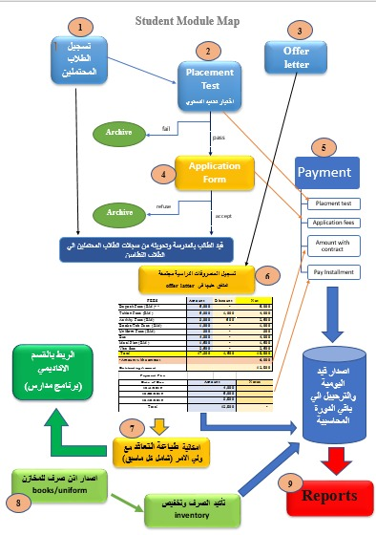

2.5

Payment for Students’ tuition fees

It will be recorded in only one screen (6) with the link and migration of each type of revenue to its account in the accounts directory

Bearing in mind that revenue items such as tuition fees, books, .....

Items such as discount, uniform and books

And also the items current liabilities such as deposit

Should be directed to their accounts chart